Michael Santoro

Bradley Morales

Julio Sarzosa

Progress Report 4

**Description:**

For this final project, we were tasked to implement a complete 5-stage pipelined MIPS datapath that is capable of executing our full instruction set. The 12 instructions of our instruction set were 7 R-Type (add, sub, and, or, not, nand, slt) and 5 I-Type (addi, lw, sw, beq, bne).

**Instruction Set:**

| Instruction | OpCode | RegDst | ALUsrc | MemtoReg | RegWrite | MemWrite | Beq | Bne | ALUCtl |
| --- | --- | --- | --- | --- | --- | --- | --- | --- | --- |
| add | 0000 | 1 | 0 | 0 | 1 | 0 | 0 | 0 | 0010 |
| sub | 0001 | 1 | 0 | 0 | 1 | 0 | 0 | 0 | 0110 |
| and | 0010 | 1 | 0 | 0 | 1 | 0 | 0 | 0 | 0000 |
| or | 0011 | 1 | 0 | 0 | 1 | 0 | 0 | 0 | 0001 |
| nor | 0100 | 1 | 0 | 0 | 1 | 0 | 0 | 0 | 1100 |
| nand | 0101 | 1 | 0 | 0 | 1 | 0 | 0 | 0 | 1101 |
| slt | 0110 | 1 | 0 | 0 | 1 | 0 | 0 | 0 | 0111 |
| addi | 0111 | 0 | 1 | 0 | 1 | 0 | 0 | 0 | 0010 |
| lw | 1000 | 0 | 1 | 1 | 1 | 0 | 0 | 0 | 0010 |
| sw | 1001 | 0 | 1 | 0 | 0 | 1 | 0 | 0 | 0010 |
| beq | 1010 | 0 | 0 | 0 | 0 | 0 | 1 | 0 | 0110 |
| bne | 1011 | 0 | 0 | 0 | 0 | 0 | 0 | 1 | 0110 |



**Logic Diagrams:**

**ALU Diagram:**

**CPU Diagram:**

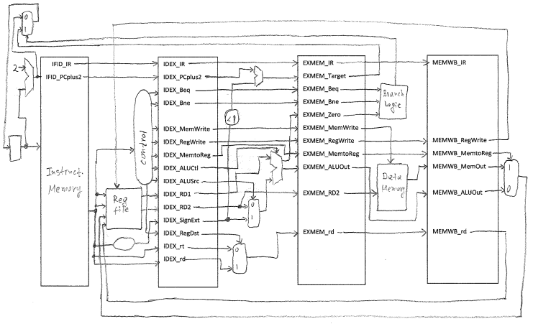

**16-Bit Full Adder Diagram:**

Note: The software used to create this diagram represents a full adder as the shape of an ALU. In this diagram these are supposed to be 16 Full-Adders strung together.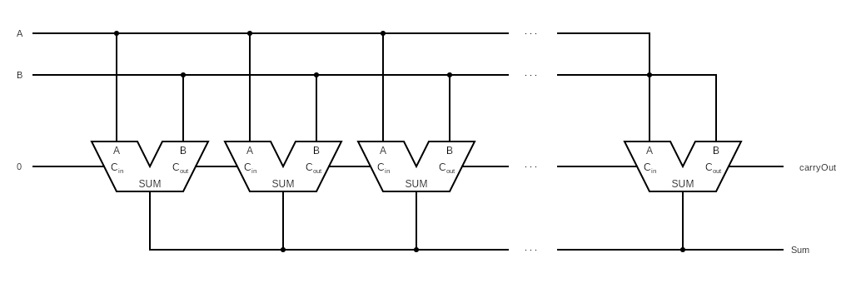

**16-Bit 2x1 Multiplexor:**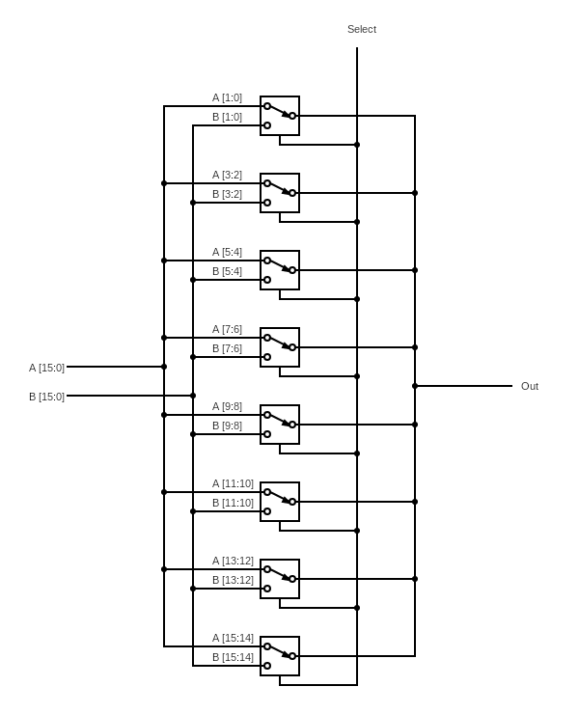

**Verilog Code:**

// Michael, Brad, Julio

// Progress Report 4

module reg_file (RR1,RR2,WR,WD,RegWrite,RD1,RD2,clock);

input [1:0] RR1,RR2,WR;

input [15:0] WD;

input RegWrite,clock;

output [15:0] RD1,RD2;

reg [15:0] Regs[0:15];

assign RD1 = Regs[RR1];

assign RD2 = Regs[RR2];

initial Regs[0] = 0;

always @(negedge clock)

if (RegWrite==1 & WR!=0)

Regs[WR] <= WD;

endmodule

// 16-bit MIPS ALU in Verilog using modified template of 4-bit ALU

module ALU (op,a,b,result,zero);

input [15:0] a;

input [15:0] b;

input [3:0] op;

output [15:0] result;

output zero;

wire c1,c2,c3,c4,c5,c6,c7,c8,c9,c10,c11,c12,c13,c14,c15,c16;

//16 single bit alu's

ALU1 alu0 (a[0], b[0], op[3], op[2], op[1:0],set,op[2],c1,result[0]);

ALU1 alu1 (a[1], b[1], op[3], op[2], op[1:0],1'b0, c1, c2,result[1]);

ALU1 alu2 (a[2], b[2], op[3], op[2], op[1:0],1'b0, c2, c3,result[2]);

ALU1 alu3 (a[3], b[3], op[3], op[2], op[1:0],1'b0, c3, c4,result[3]);

ALU1 alu4 (a[4], b[4], op[3], op[2], op[1:0],1'b0, c4, c5,result[4]);

ALU1 alu5 (a[5], b[5], op[3], op[2], op[1:0],1'b0, c5, c6,result[5]);

ALU1 alu6 (a[6], b[6], op[3], op[2], op[1:0],1'b0, c6, c7,result[6]);

ALU1 alu7 (a[7], b[7], op[3], op[2], op[1:0],1'b0, c7, c8,result[7]);

ALU1 alu8 (a[8], b[8], op[3], op[2], op[1:0],1'b0, c8, c9,result[8]);

ALU1 alu9 (a[9], b[9], op[3], op[2], op[1:0],1'b0, c9, c10,result[9]);

ALU1 alu10 (a[10],b[10],op[3], op[2], op[1:0],1'b0, c10, c11,result[10]);

ALU1 alu11 (a[11],b[11],op[3], op[2], op[1:0],1'b0, c11, c12,result[11]);

ALU1 alu12 (a[12],b[12],op[3], op[2], op[1:0],1'b0, c12, c13,result[12]);

ALU1 alu13 (a[13],b[13],op[3], op[2], op[1:0],1'b0, c13, c14,result[13]);

ALU1 alu14 (a[14],b[14],op[3], op[2], op[1:0],1'b0, c14, c15,result[14]);

ALUmsb alu15 (a[15],b[15],op[3], op[2], op[1:0],1'b0, c15, c16,result[15],set);

nor nor1(zero,result [15:0]);

endmodule

// 1-bit ALU for bits 0-14

module ALU1 (a,b,ainvert,binvert,op,less,carryin,carryout,result);

input a,b,less,carryin,ainvert, binvert;

input [1:0] op;

output carryout,result;

wire sum, a_and_b, a_or_b, b_inv, a_inv;

// Choose if we use a or a invert

not not1(a_inv, a);

mux2x1 mux1(a,a_inv,ainvert,a1);

// Chose if we use b or b invert

not not2(b_inv, b);

mux2x1 mux2(b,b_inv,binvert,b1);

and and1(a_and_b, a1, b1);

or or1(a_or_b, a1, b1);

fulladder adder1(sum,carryout,a1,b1,carryin);

mux4x1 mux3(a_and_b,a_or_b,sum,less,op[1:0],result);

endmodule

// 1-bit ALU for smb

module ALUmsb (a,b,ainvert, binvert,op,less,carryin,carryout,result,sum);

input a,b,less,carryin,ainvert,binvert;

input [1:0] op;

output carryout,result,sum;

wire sum, a_and_b, a_or_b, b_inv, a_inv;

// Choose if we use a or a invert

not not1(a_inv, a);

mux2x1 mux1(a,a_inv,ainvert,a1);

// Choose if we use b or b invert

not not2(b_inv, b);

mux2x1 mux2(b,b_inv,binvert,b1);

and and1(a_and_b, a1, b1);

or or1(a_or_b, a1, b1);

fulladder adder1(sum,carryout,a1,b1,carryin);

mux4x1 mux3(a_and_b,a_or_b,sum,less,op[1:0],result);

endmodule

// Adders

module halfadder (S,carryOut,A,B);

input A,B;

output S,carryOut;

xor (S,A,B);

and (carryOut,A,B);

endmodule

module fulladder (S,carryOut,A,B,carryIn);

input A,B,carryIn;

output S,carryOut;

wire S1,D1,D2;

halfadder HA1 (S1,D1,A,B),

HA2 (S,D2,S1,carryIn);

or g1(carryOut,D2,D1);

endmodule

// Multiplexors

// 16-bit 4x1 Mux

module mux16bit(a, b, c, d, select, OUT);

input [15:0] a, b, c, d;

input [1:0] select;

output [15:0] OUT;

//16 4x1 mux

mux4x1 mux0(a[0], b[0], c[0], d[0], select, OUT[0]);

mux4x1 mux1(a[1], b[1], c[1], d[1], select, OUT[1]);

mux4x1 mux2(a[2], b[2], c[2], d[2], select, OUT[2]);

mux4x1 mux3(a[3], b[3], c[3], d[3], select, OUT[3]);

mux4x1 mux4(a[4], b[4], c[4], d[4], select, OUT[4]);

mux4x1 mux5(a[5], b[5], c[5], d[5], select, OUT[5]);

mux4x1 mux6(a[6], b[6], c[6], d[6], select, OUT[6]);

mux4x1 mux7(a[7], b[7], c[7], d[7], select, OUT[7]);

mux4x1 mux8(a[8], b[8], c[8], d[8], select, OUT[8]);

mux4x1 mux9(a[9], b[9], c[9], d[9], select, OUT[9]);

mux4x1 mux10(a[10], b[10], c[10], d[10], select, OUT[10]);

mux4x1 mux11(a[11], b[11], c[11], d[11], select, OUT[11]);

mux4x1 mux12(a[12], b[12], c[12], d[12], select, OUT[12]);

mux4x1 mux13(a[13], b[13], c[13], d[13], select, OUT[13]);

mux4x1 mux14(a[14], b[14], c[14], d[14], select, OUT[14]);

mux4x1 mux15(a[15], b[15], c[15], d[15], select, OUT[15]);

endmodule

// 1-bit 4x1 Mux

module mux4x1(a,b,c,d,select,OUT);

input a,b,c,d;

input [1:0] select;

output OUT;

mux2x1 mux1(a, b, select[0], m1);

mux2x1 mux2(c, d, select[0], m2);

mux2x1 mux3(m1, m2, select[1], OUT);

endmodule

// 16-bit 2x1 Mux

// Rewritten For Extra Work to use 8 2-bit 2x1 Mux's instead of 16 1-bit 2x1 Mux's

module mux2x1_16bit(A, B, select, OUT);

input [15:0] A,B;

input select;

output [15:0] OUT;

//8 2-bit 2x1 mux's

mux2x1_2bit mux1(A[1:0],B[1:0],select,OUT[1:0]);

mux2x1_2bit mux2(A[3:2],B[3:2],select,OUT[3:2]);

mux2x1_2bit mux3(A[5:4],B[5:4],select,OUT[5:4]);

mux2x1_2bit mux4(A[7:6],B[7:6],select,OUT[7:6]);

mux2x1_2bit mux5(A[9:8],B[9:8],select,OUT[9:8]);

mux2x1_2bit mux6(A[11:10],B[11:10],select,OUT[11:10]);

mux2x1_2bit mux7(A[13:12],B[13:12],select,OUT[13:12]);

mux2x1_2bit mux8(A[15:14],B[15:14],select,OUT[15:14]);

endmodule

// 2-bit 2x1 Mux

module mux2x1_2bit(A,B,select,OUT);

input [1:0] A,B;

input select;

output [1:0] OUT;

//2 2x1 muxs

mux2x1 mux1(A[0], B[0], select, OUT[0]),

mux2(A[1], B[1], select, OUT[1]);

endmodule

// 1-bit 2x1 Mux

module mux2x1(A,B,select,OUT);

input A,B,select;

output OUT;

not not1(i0, select);

and and1(i1, A, i0);

and and2(i2, B, select);

or or1(OUT, i1, i2);

endmodule

module MainControl (Op,Control);

input [3:0] Op;

output reg [10:0] Control;

// RegDst,ALUSrc,MemtoReg,RegWrite,MemWrite,Beq,Bne,ALUOp;

always @(Op) case (Op)

4'b0000: Control <= 11'b10010_00_0010; // add

4'b0001: Control <= 11'b10010_00_0110; // sub

4'b0010: Control <= 11'b10010_00_0000; // and

4'b0011: Control <= 11'b10010_00_0001; // or

4'b0100: Control <= 11'b10010_00_1101; // nor

4'b0101: Control <= 11'b10010_00_1100; // nand

4'b0110: Control <= 11'b10010_00_0111; // slt

4'b0111: Control <= 11'b01010_00_0010; // adii

4'b1000: Control <= 11'b01110_00_0010; // lw

4'b1001: Control <= 11'b01001_00_0010; // sw

4'b1010: Control <= 11'b00000_10_0110; // beq

4'b1011: Control <= 11'b00000_01_0110; // bne

endcase

endmodule

module CPU (clock,PC,IFID_IR,IDEX_IR,EXMEM_IR,MEMWB_IR,WD);

input clock;

output [15:0] PC,IFID_IR,IDEX_IR,EXMEM_IR,MEMWB_IR,WD;

initial begin

// Program: swap memory cells (if needed) and compute absolute value |5-7|=2

IMemory[0] = 16'b1000_00_01_00000000; // lw $t1, 0($0)

IMemory[1] = 16'b1000_00_10_00000010; // lw $t2, 2($0)

IMemory[2] = 16'b0000000000000000; // nop

IMemory[3] = 16'b0000000000000000; // nop

IMemory[4] = 16'b0000000000000000; // nop

IMemory[5] = 16'b0110_01_10_11_000000; // slt $t3, $t1, $t2

IMemory[6] = 16'b0000000000000000; // nop

IMemory[7] = 16'b0000000000000000; // nop

IMemory[8] = 16'b0000000000000000; // nop

IMemory[9] = 16'b1010_11_00_00000110; // beq $t3, $0, IMemory[15]

IMemory[10]= 16'b0000000000000000; // nop

IMemory[11]= 16'b0000000000000000; // nop

IMemory[12]= 16'b0000000000000000; // nop

IMemory[13]= 16'b1001_00_01_00000010; // sw $t1, 2($0)

IMemory[14]= 16'b1001_00_10_00000000; // sw $t2, 0($0)

IMemory[15]= 16'b0000000000000000; // nop

IMemory[16]= 16'b0000000000000000; // nop

IMemory[17]= 16'b0000000000000000; // nop

IMemory[18]= 16'b1000_00_01_00000000; // lw $t1, 0($0)

IMemory[19]= 16'b1000_00_10_00000010; // lw $t2, 4($0)

IMemory[20]= 16'b0000000000000000; // nop

IMemory[21]= 16'b0000000000000000; // nop

IMemory[22]= 16'b0000000000000000; // nop

IMemory[23]= 16'b0100_10_10_10_000000; // nor $t2, $t2, $t2 (it invert all bits)

IMemory[24]= 16'b0000000000000000; // nop

IMemory[25]= 16'b0000000000000000; // nop

IMemory[26]= 16'b0000000000000000; // nop

IMemory[27]= 16'b0111_10_10_00000001; // addi $t2, $t2, 1

IMemory[28]= 16'b0000000000000000; // nop

IMemory[29]= 16'b0000000000000000; // nop

IMemory[30]= 16'b0000000000000000; // nop

IMemory[31]= 16'b0000_01_10_11_000000; // add $t3, $t1, $t2

// Data

DMemory[0] = 5; // switch the cells and see how the simulation output changes

DMemory[1] = 7; // (beq is taken if DMemory[0]=7; DMemory[1]=5, not taken otherwise)

end

// Pipeline

// IF

wire [15:0] PCplus4, NextPC;

reg[15:0] PC, IMemory[0:1023], IFID_IR, IFID_PCplus4;

ALU fetch (4'b0010,PC,16'd2,PCplus4,Unused1);

mux2x1_16bit m1 (PCplus4,EXMEM_Target, (EXMEM_Beq && EXMEM_Zero || EXMEM_Bne && ~EXMEM_Zero ),NextPC);

// ID

wire [10:0] Control;

reg IDEX_RegWrite,IDEX_MemtoReg,

IDEX_Beq, IDEX_Bne, IDEX_MemWrite,

IDEX_ALUSrc, IDEX_RegDst;

reg [3:0] IDEX_ALUOp;

wire [15:0] RD1,RD2,SignExtend, WD;

reg [15:0] IDEX_PCplus4,IDEX_RD1,IDEX_RD2,IDEX_SignExt,IDEXE_IR;

reg [15:0] IDEX_IR; // For monitoring the pipeline

reg [1:0] IDEX_rt,IDEX_rd;

reg MEMWB_RegWrite; // part of MEM stage, but declared here before use (to avoid error)

reg [1:0] MEMWB_rd; // part of MEM stage, but declared here before use (to avoid error)

reg_file rf (IFID_IR[11:10],IFID_IR[9:8],MEMWB_rd,WD,MEMWB_RegWrite,RD1,RD2,clock);

MainControl MainCtr (IFID_IR[15:12],Control);

assign SignExtend = {{8{IFID_IR[7]}},IFID_IR[7:0]};

// EXE

reg EXMEM_RegWrite,EXMEM_MemtoReg,

EXMEM_Beq, EXMEM_Bne, EXMEM_MemWrite;

wire [15:0] Target;

reg EXMEM_Zero;

reg [15:0] EXMEM_Target,EXMEM_ALUOut,EXMEM_RD2;

reg [15:0] EXMEM_IR; // For monitoring the pipeline

reg [1:0] EXMEM_rd;

wire [15:0] B,ALUOut;

wire [1:0] WR;

ALU branch (4'b0010,IDEX_SignExt<<2,IDEX_PCplus4,Target,Unused2);

ALU ex (IDEX_ALUOp, IDEX_RD1, B, ALUOut, Zero);

mux2x1_16bit m2 (IDEX_RD2,IDEX_SignExt,IDEX_ALUSrc,B); // ALUSrc Mux

mux2x1_2bit m3 (IDEX_rt,IDEX_rd,IDEX_RegDst,WR); // RegDst Mux

// MEM

reg MEMWB_MemtoReg;

reg [15:0] DMemory[0:1023],MEMWB_MemOut,MEMWB_ALUOut;

reg [15:0] MEMWB_IR; // For monitoring the pipeline

wire [15:0] MemOut;

assign MemOut = DMemory[EXMEM_ALUOut>>1];

always @(negedge clock) if (EXMEM_MemWrite) DMemory[EXMEM_ALUOut>>1] <= EXMEM_RD2;

// WB

mux2x1_16bit m4 (MEMWB_ALUOut,MEMWB_MemOut,MEMWB_MemtoReg,WD); // MemtoReg Mux

initial begin

PC = 0;

// Initialize pipeline registers

IDEX_RegWrite=0;IDEX_MemtoReg=0;IDEX_Beq=0;IDEX_Bne=0;IDEX_MemWrite=0;IDEX_ALUSrc=0;IDEX_RegDst=0;IDEX_ALUOp=0;

IFID_IR=0;

EXMEM_RegWrite=0;EXMEM_MemtoReg=0;EXMEM_Beq=0;EXMEM_Bne=0;EXMEM_MemWrite=0;

EXMEM_Target=0;

MEMWB_RegWrite=0;MEMWB_MemtoReg=0;

end

// Running the pipeline

always @(negedge clock) begin

// IF

PC <= NextPC;

IFID_PCplus4 <= PCplus4;

IFID_IR <= IMemory[PC>>1];

// ID

IDEX_IR <= IFID_IR; // For monitoring the pipeline

{IDEX_RegDst,IDEX_ALUSrc,IDEX_MemtoReg,IDEX_RegWrite,IDEX_MemWrite,IDEX_Beq,IDEX_Bne,IDEX_ALUOp} <= Control;

IDEX_PCplus4 <= IFID_PCplus4;

IDEX_RD1 <= RD1;

IDEX_RD2 <= RD2;

IDEX_SignExt <= SignExtend;

IDEX_rt <= IFID_IR[9:8];

IDEX_rd <= IFID_IR[7:6];

// EXE

EXMEM_IR <= IDEX_IR; // For monitoring the pipeline

EXMEM_RegWrite <= IDEX_RegWrite;

EXMEM_MemtoReg <= IDEX_MemtoReg;

EXMEM_Beq <= IDEX_Beq;

EXMEM_Bne <= IDEX_Bne;

EXMEM_MemWrite <= IDEX_MemWrite;

EXMEM_Target <= Target;

EXMEM_Zero <= Zero;

EXMEM_ALUOut <= ALUOut;

EXMEM_RD2 <= IDEX_RD2;

EXMEM_rd <= WR;

// MEM

MEMWB_IR <= EXMEM_IR; // For monitoring the pipeline

MEMWB_RegWrite <= EXMEM_RegWrite;

MEMWB_MemtoReg <= EXMEM_MemtoReg;

MEMWB_MemOut <= MemOut;

MEMWB_ALUOut <= EXMEM_ALUOut;

MEMWB_rd <= EXMEM_rd;

// WB

// Register write happens on neg edge of the clock (if MEMWB_RegWrite is asserted)

end

endmodule

// Test module

module test ();

reg clock;

wire signed [15:0] PC,IFID_IR,IDEX_IR,EXMEM_IR,MEMWB_IR,WD;

CPU test_cpu(clock,PC,IFID_IR,IDEX_IR,EXMEM_IR,MEMWB_IR,WD);

always #1 clock = ~clock;

initial begin

$display ("PC IFID_IR IDEX_IR EXMEM_IR MEMWB_IR WD");

$monitor ("%3d %b %b %b %b %2d",PC,IFID_IR,IDEX_IR,EXMEM_IR,MEMWB_IR,WD);

clock = 1;

#69 $finish;

end

endmodule

**Output:**

beq taken

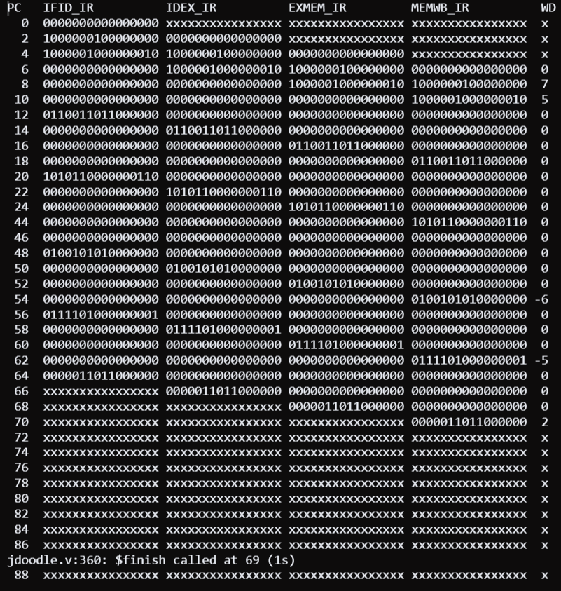

beq not taken

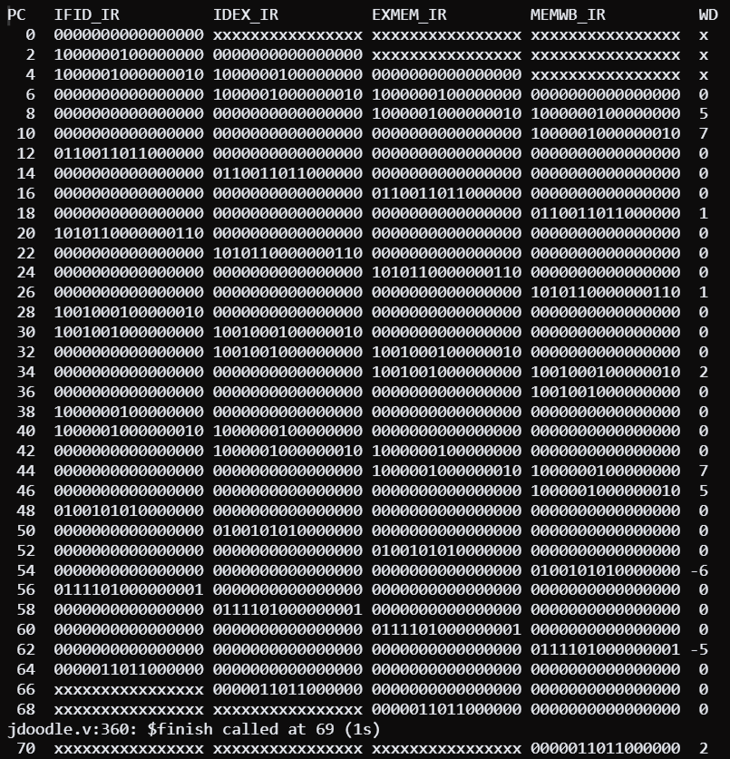

bne taken

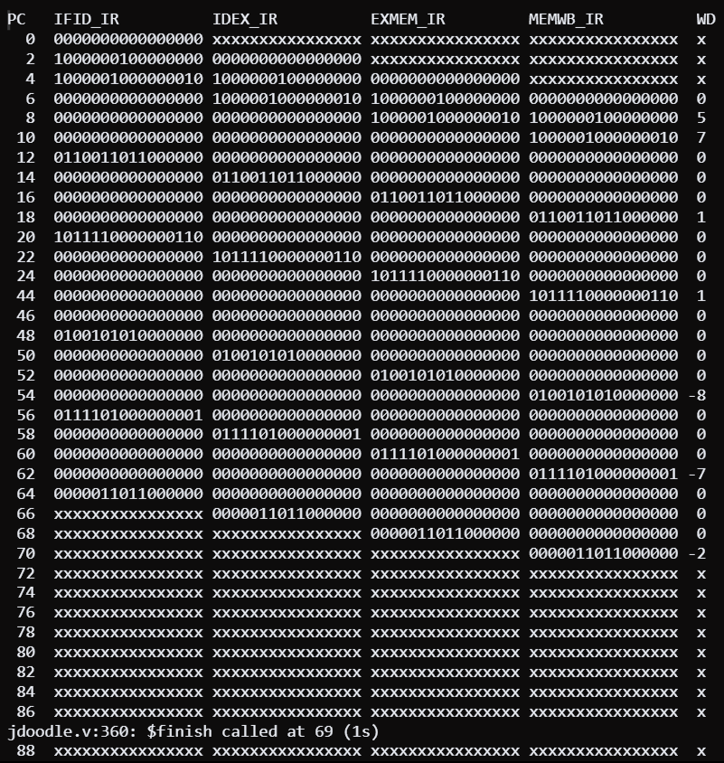

bne not taken

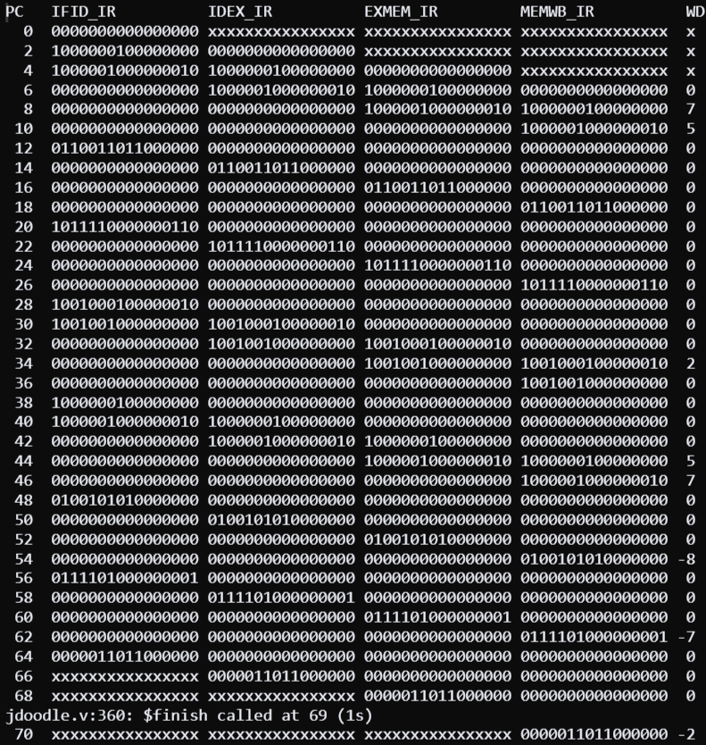

beq not taken without nops

